**CO654 Cloud Computing CW2**

**2016-2017 Submission**

**Tutor**

Rafid Al-Khannak

**Student Name**

Robert Collcott

**Student ID**

21302939

**Session Time and Day**

9:00 AM

to

12:00 PM

Thursdays

**Introduction**

This technical report they will be spilt into 2 main parts and 1 sub part these are going to be the following

* The implementation of a cloud system using the Amazon Web Services platform which is spilt into 4 sub sections
  + Launching Amazon Web Service instances
  + Creation of a cloud system load balancer
  + Monitoring using a professional industry cloud monitoring watching tool
  + Creation of a cloud database using an industry cloud storage service tool
* A Research topic which in this case is Cloud Based Models which are Software as a Service Platform as a Service and Infrastructure as a Service which the following concepts of each will be discussed
  + Discussing each model
  + Comparing each model
  + Comparing all three models via a table grid on the precise features of the models
* A case study taking into account a real world situation within Cloud Computing

CO654 Cloud Computing Assignment 2 2016-2017 Contents

Task 1A – Registering and Setting up the cloud system using the Amazon web services 6

Instances and VPC ID 6

Instances Status EU Frankfurt Region 6

Instances Status EU Ireland Region 7

Difference between Private and Public DNS 8

Difference between Private and Public IP 9

Difference between Private and Public DNS 9

Running Zones 10

Security Group 11

Launching Time 12

Task 1B – Creation of the Load Balancer 13

Task 1B – Creation of the Load Balancer 14

Public DNS name 15

Load Balancer Status 16

Availability Zones 17

Hosted Zone ID 18

VPC ID 18

Instance Status 19

Task 1C – Using the AWS Cloud watch monitoring tool 20

The Percentage of average statistics of CPU Utilisation during the first two days of your system setting and for each 15 minutes’ cycle 20

CPU Credit Usage 23

EU Ireland 24

Amount of Bytes read in the same period 25

EU Ireland 25

EU Frankfurt 26

Status of Failed instances during the last 3 days with 5 minute checks 27

Healthy and un healthy hosts on my cloud system for a three day period 28

EU Ireland Region 28

Task 1D -- Create your Cloud database, name your Buckets as “mycwdb”. Inside your Bucket do the following: 31

Creation of two folders named fcone and fctwo 32

Task 2 – The Research Topic – Cloud Based Models [SASS PAAS and IAAS] 37

Cloud Computing Technical Definition 37

Typical types of cloud computing 37

Cloud Computing Models basic outline of characteristics 38

Software as a Service [SASS Model Overview] 38

Basic characteristics of SAAS [Software as a Service] 42

Software as a Service Advantages 43

Software as a Service Disadvantages 43

PAAS Model overview 44

Platform as a Service Advantages 45

Platform as a Service Disadvantages 46

Infrastructure as a Service 46

IAAS Model overview 48

Infrastructure as a Service Advantages 49

Infrastructure as a Service Disadvantages 49

Industry examples of how infrastructure can be used by an enterprise such as Amazon Web Services 49

Security Concepts 50

SAAS PAAS and IAAS detailed features comparison 51

SASS PASS and IASS Economic Benefits 52

Case Study - A+ Test Prep and Tutoring overview 53

Case Study - A+ Test Prep and Tutoring suggestions 54

Cloud Computing Assignment 2 References List 55

Task 1

The Technical Task

The Building of a Cloud Computing System

## Task 1A – Registering and Setting up the cloud system using the Amazon web services

## Instances and VPC ID

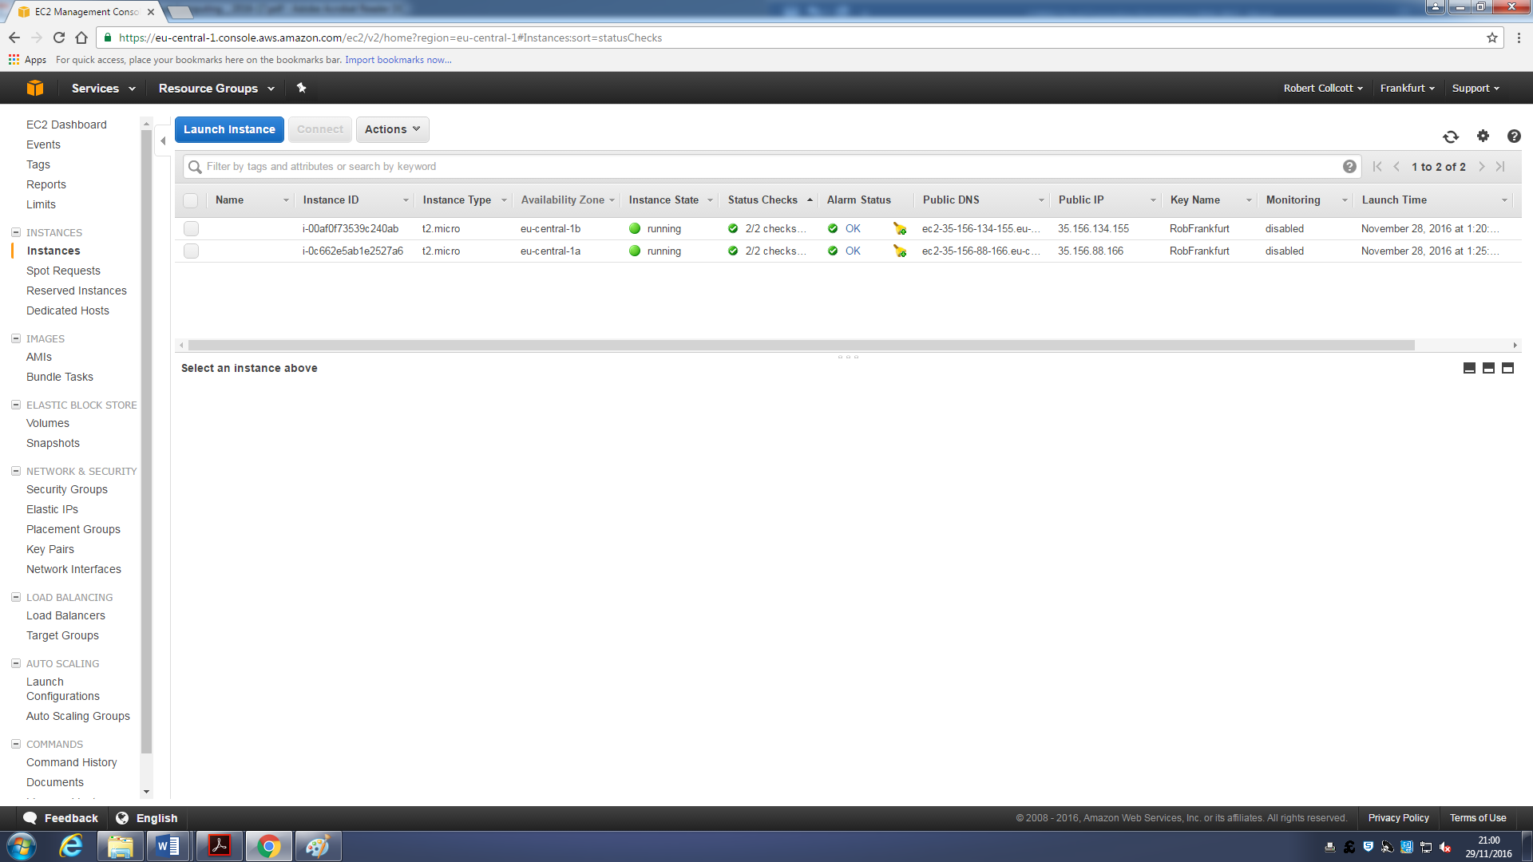

Figure 1 My created AWS instances in the EU Frankfurt Region

Here are all my instances in the EU Frankfurt Region in this screenshot the user is showing in particular the Instance ID and VPC ID

VPC ID in Cloud Computing stands for **Virtual Private Cloud**

Amazon VPC lets you provision a logically isolated section of the AWS cloud when you can launch AWS resources that you define these happen in a virtual network with complete control over the following below

* IP Address range
* Subnet creation
* Configuration of route tables
* Network gateways

All the above have the ability to work with IPv4 and IPv6 addressing schemes for secure easy access to the resources and applications that a user desires

## C:\Users\Robert Collcott\AppData\Local\Microsoft\Windows\INetCache\Content.Word\task 1 a.pngInstances Status EU Frankfurt Region

Figure 2 This is showing the instance status in the EU Frankfurt region

## Instances Status EU Ireland Region

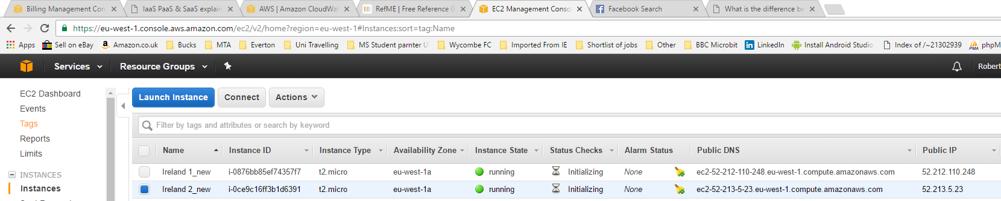

Figure 3 This is showing the created instance in EU Ireland status in the EU Ireland region



## Difference between Private and Public DNS

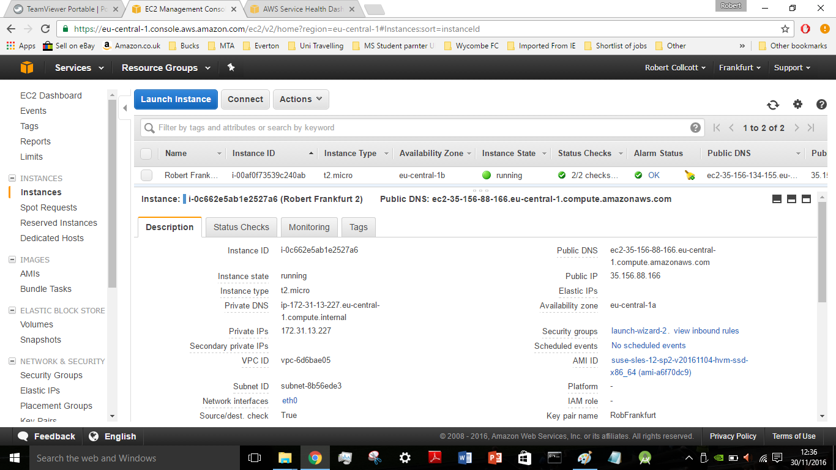

Figure 4 Showing the Public DNS Private DNS Private and Public IP on a EU Frankfurt instance

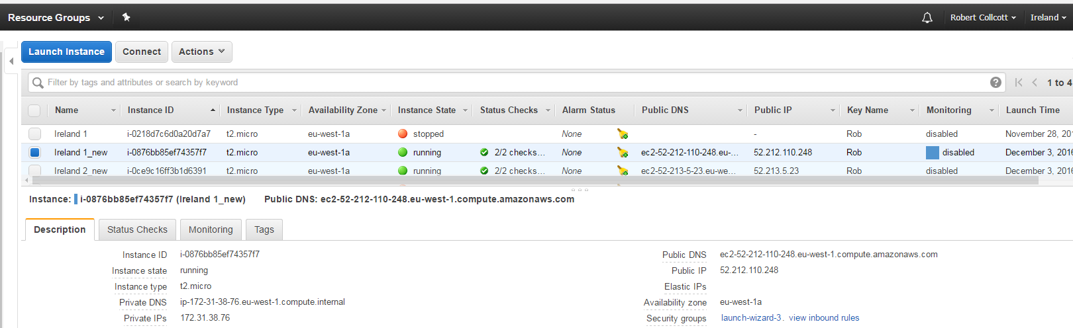 Figure 5 Showing the Public DNS Private DNS Private and Public IP on a EU Ireland instance

## Difference between Private and Public IP

A public IP address us an IP address that can be accessed over the internet these are globally unique to a particular computing device e.g. phone tablet or desktop computer etc.

Private IP addresses on the other hand are used to assign computers with a private space, for example if you have multiple computers within one home or in one office can get a private IP address from the router’s DHCP protocol.

The industry board named the **Internet Assigned Numbers Authority** is the organization responsible for registering IP address range to organisations and Internet service providers this allows organisations freely to assign private IP addresses.

Then the network interface card has certain blocks reserved for a private IP address a very good example is a family home printer this is given a private IP so only the family that own the device can print nobody else

## Difference between Private and Public DNS

**Internal Private DNS**

Is the one a Domain Name Server or Service that is in your own personal network for example in your own house if you had a broadband router then this will be internal DNS this tells each of your computers connected to your broadband connection what its local identity is

**External Public DNS**

Is the one used by your internet service provider but with other companies on the internet to tell the web browser for example using Google Chrome to find where different websites and computers are in the world. The major difference is from Internal DNS is you cannot configure directly unless you have and own an internet domain of your own in which case you would configure it with whatever software the domain you purchased provided you with

## Running Zones



Figure 6 Showing instances running zone for EU Frankfurt is eu-central 1a

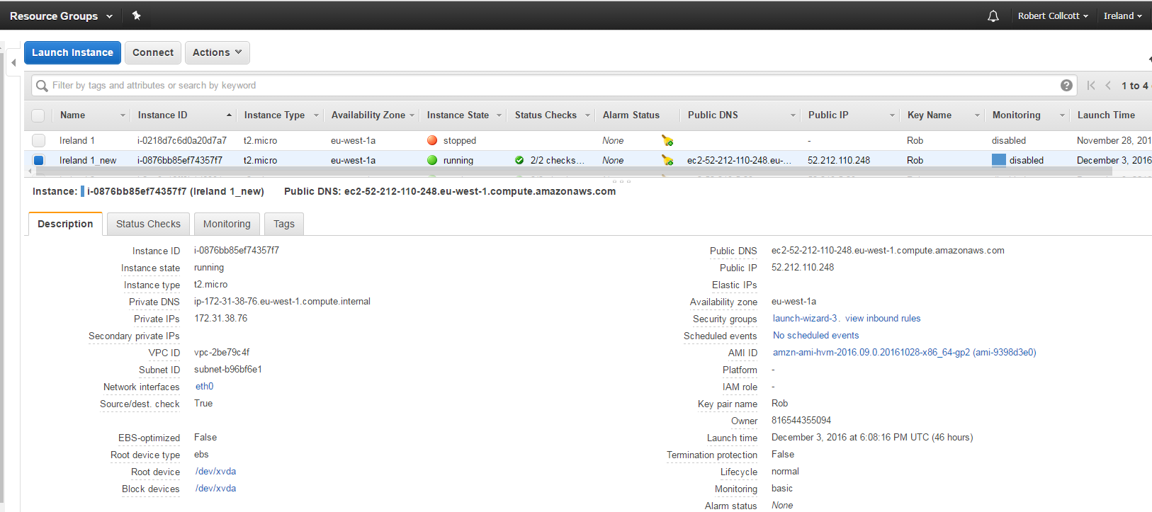

*Figure 7 Showing instances running zone for EU Ireland is eu-central 1a*

## Security Group



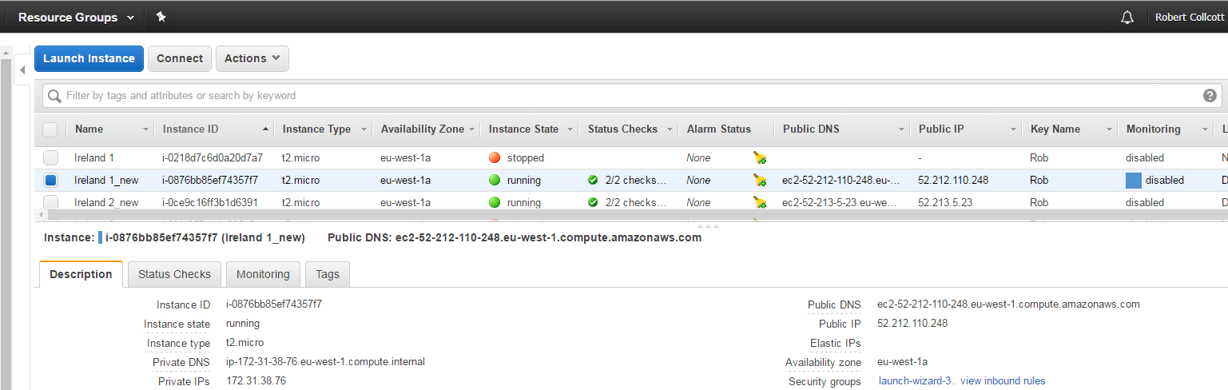

Figure 9 Showing the security group that the Ireland instances belong too

Figure 8 Showing the security group that the Frankfurt instances belong too

## Launching Time

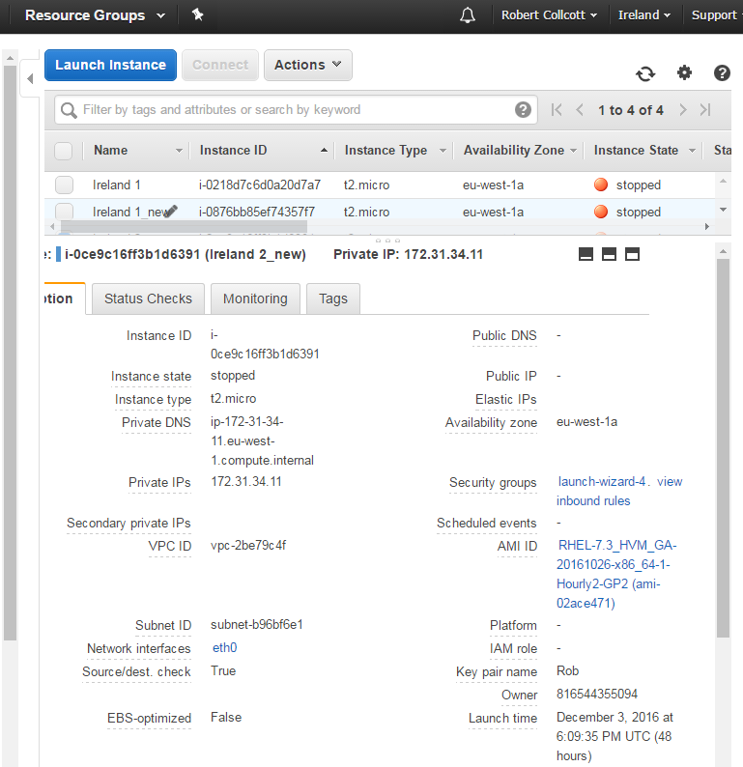

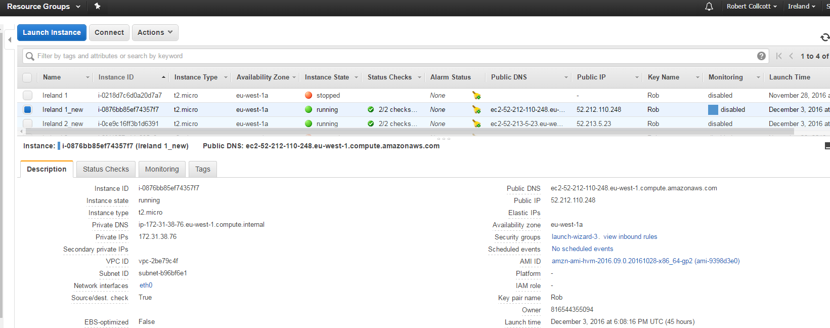

*Figure 10 Showing the launching time on an Ireland instance*

*Figure 11 Showing the launching time on a Frankfurt instance*

## Task 1B – Creation of the Load Balancer

I used a classic load balancer to do the following tasks. However, I researched what is a load balancer for some industry ready research to prep me up for a cloud based job should I take the path in the future.

I used a classic load balancer, which was an advantage because of the following aspects below

**High Availability**

I could distribute traffic across a single Amazon EC2 instance in a single availability zone or multiple zones

**Health Checking**

I used the classic load balancer, as one of the client requirements was to try to see the health statues of the instances created.

**Security features**

I could create and manage security groups as this provides additional security options such as additional ports e.g. Port 80 for HTTP.

## Task 1B – Creation of the Load Balancer

I created a load balancer to monitor and check EC2 instances health

**What does a load balancer in cloud computing actually do?**

A load balancer automatically distributes traffic across multiple instances it helps users achieve fault tolerance in your applications seamlessly providing the required amount of load balancing to route application traffic

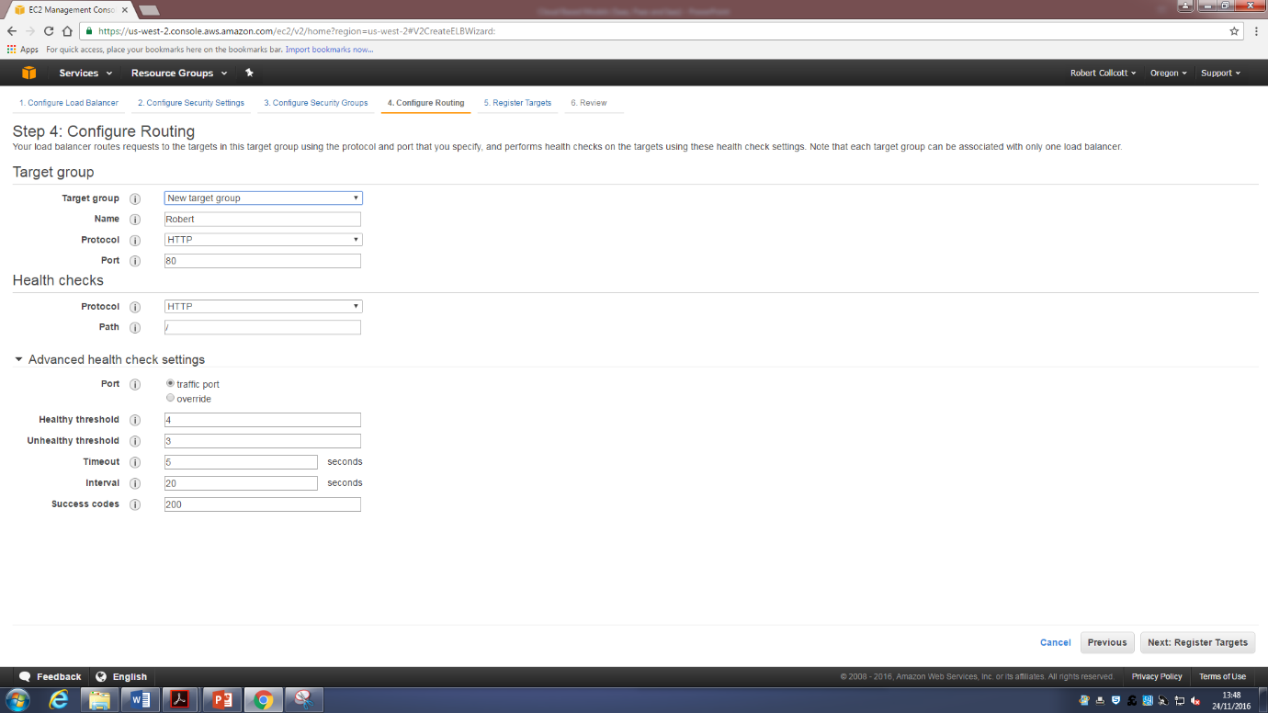

Figure 12 showing the creation of a load balancer with the following settings as per instructed via the Assignment brief

* *3 seconds when receiving from a health check*
* *20 seconds between health checks*
* *3 times before declaring an EC2 instance un healthy and removing it from the load balancer*
* *4 successful health checks before declaring a EC2 instance healthy*
* *Not allowing the traffic to distribute across multiple zones*

One benefit of load balancing on AWS is that it works with Amazon Virtual Private cloud to provide robust networking security features and you can even set the load balancer to be just internal to route to private IP addresses

## Public DNS name

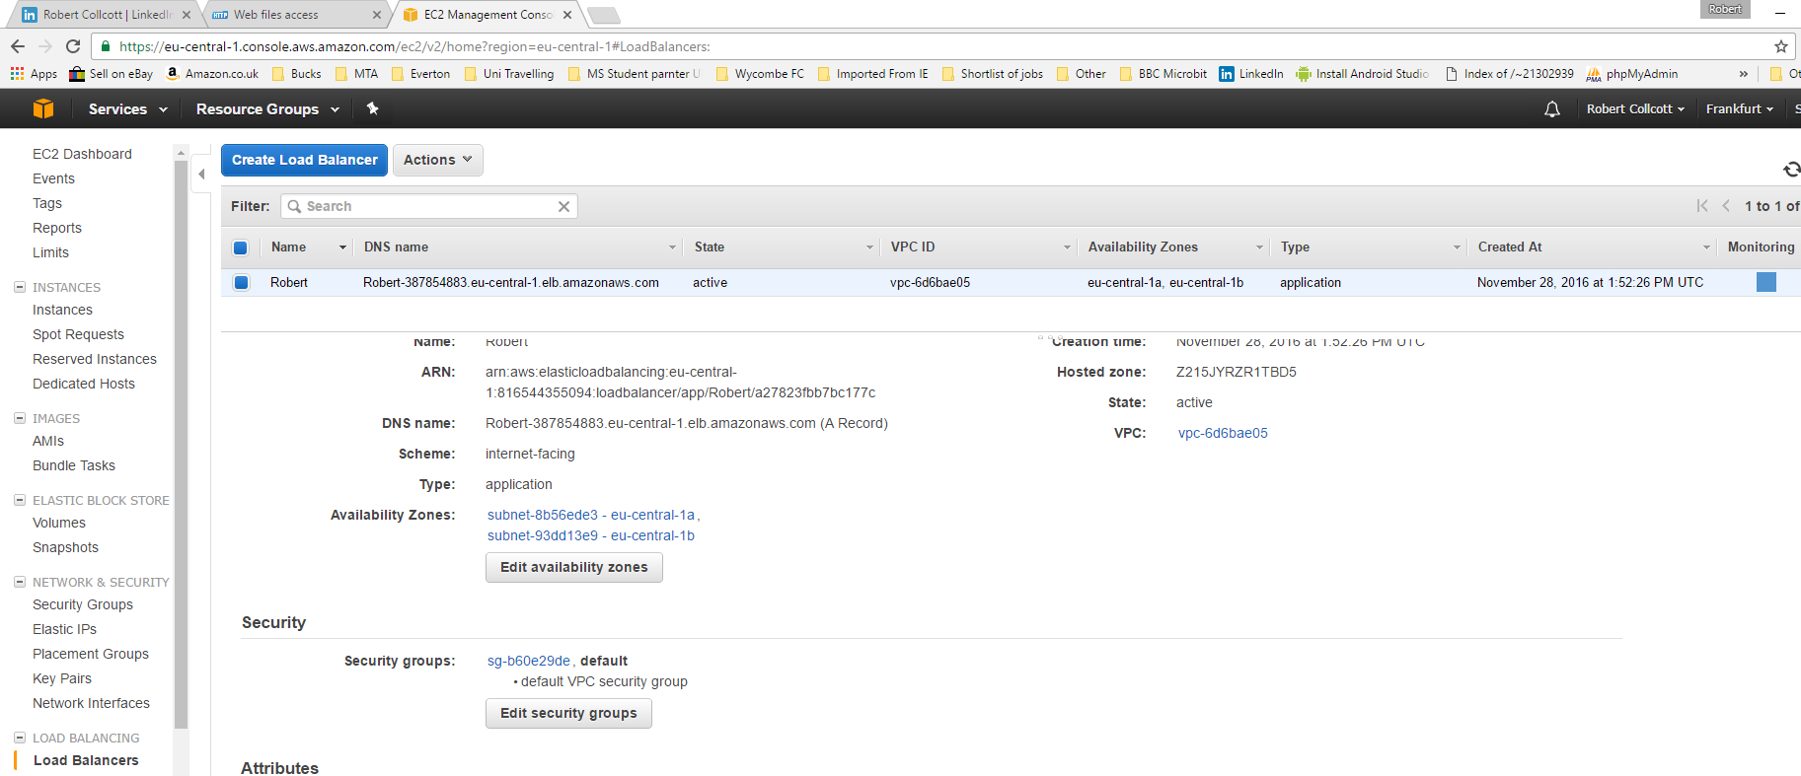

Figure 13 showing of the load balancer’s public DNS name on the EU Frankfurt Region

as this is where my load balancer is stored in my solution

## Load Balancer Status



Figure 14 Showing the load balancer status in my AWS Cloud solution on the EU Frankfurt Region

## Availability Zones



Figure 15 Showing the Availability Zone in my AWS Cloud solution on the EU Frankfurt Region

## Hosted Zone ID



Figure 16 showing of the Hosted Zone ID of my load balancer in the Frankfurt region

## VPC ID

Figure 13 Showing of the VPC ID of my load balancer in the EU Frankfurt region

## Instance Status



Figure 17 showing of the Instances status of my load balancer in the Frankfurt region

## Task 1C – Using the AWS Cloud watch monitoring tool

Using the Cloud watch management tool

I was using Amazon cloud watch to monitor the following tasks below. Amazon cloud watch is a monitoring for monitoring AWS cloud resources that are run on AWS. Amazon CloudWatch can also be used track metrics monitor log files set alarms and CloudWatch can also monitor AWS resources such as a EC2 instance e.g. **A Red Hat Linux Enterprise Server.**

The following will be shown in the 2 instances on each of the EU Frankfurt region and EU Ireland region

* Percentage of average stats of CPU Utilization with a view for first 3 days and 15 minutes’ cycle
* Bytes have been read
* Amount of data transferred via Network during the last 2 days
* Status of any failed instances
* Sum of CPU credit usage during two days for every hour
* Healthy and Un Healthy hosts on the cloud system for a three day period

## The Percentage of average statistics of CPU Utilisation during the first two days of your system setting and for each 15 minutes’ cycle

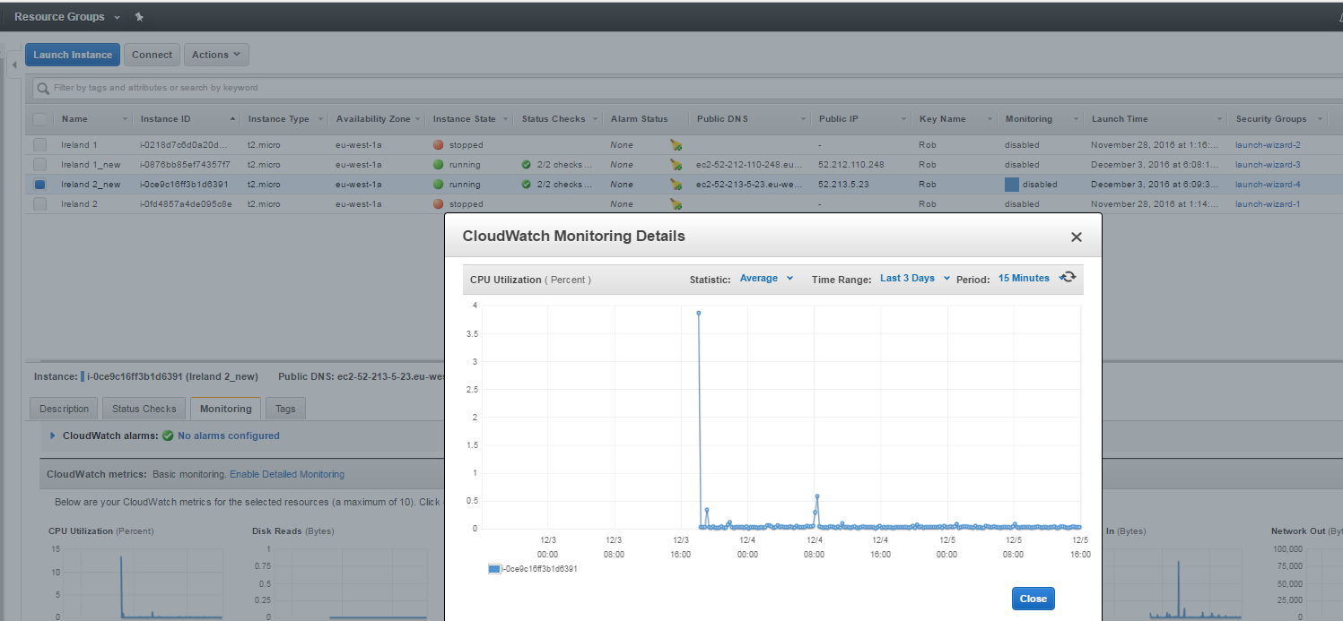EU Ireland Region

Figure 18 Showing the following for the EU Ireland Instance 1

* *Percentage of average stats of CPU Utilization with a view for first 3 days and 15 minutes’ cycle*

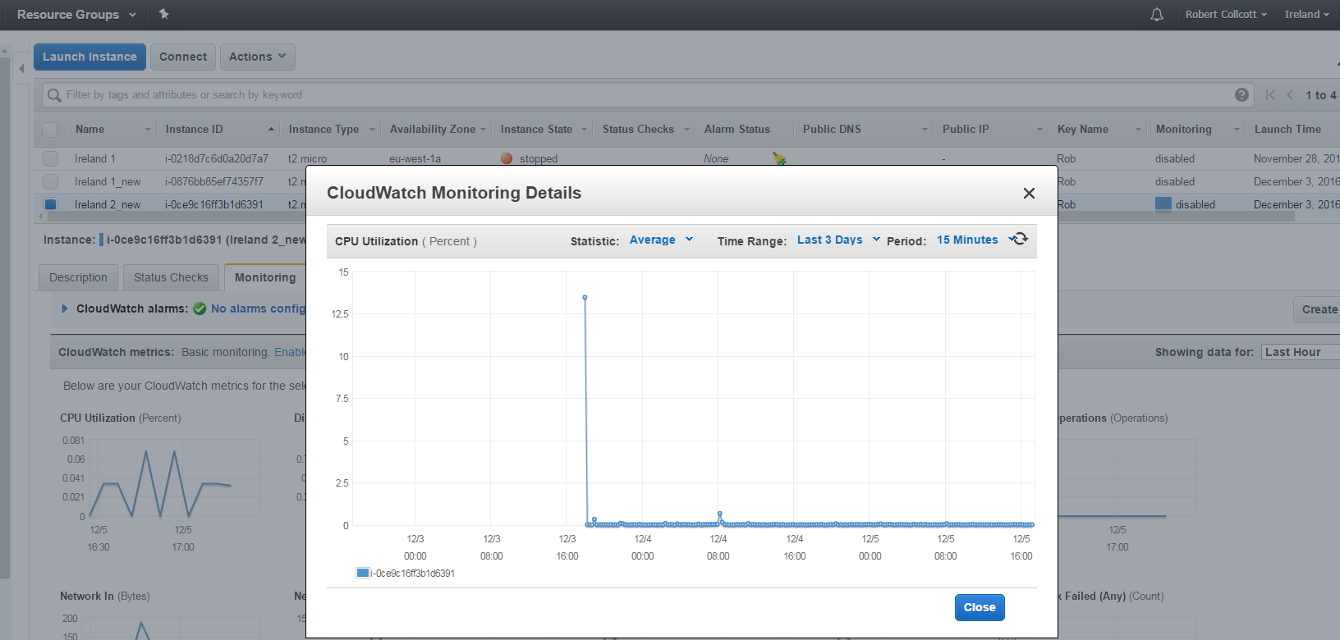

Figure 19 Showing the following for the EU Ireland Instance 2

* *Percentage of average stats of CPU Utilization with a view for first 3 days and 15 minutes’ cycle*

EU Frankfurt Region

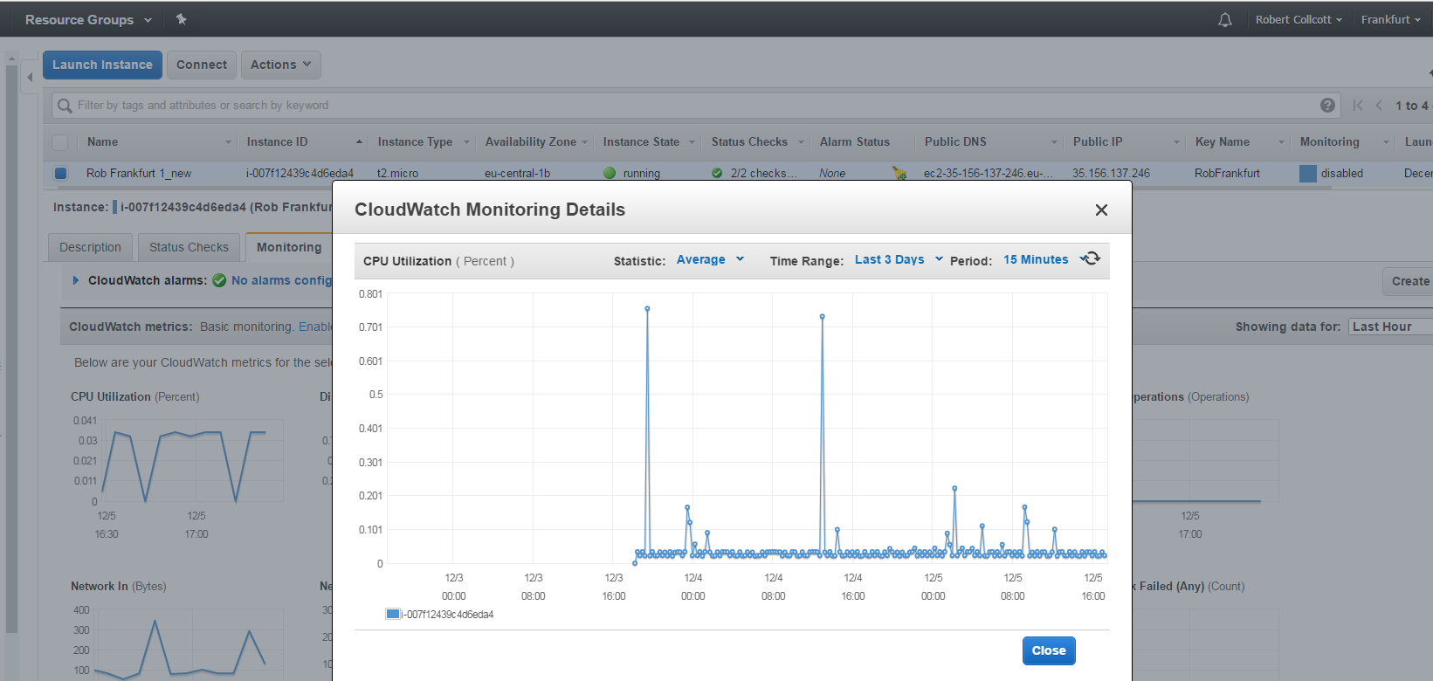

*Figure 20 Showing the following for the EU Frankfurt Instance 1*

* *Percentage of average stats of CPU Utilization with a view for first 3 days and 15 minutes’ cycle*

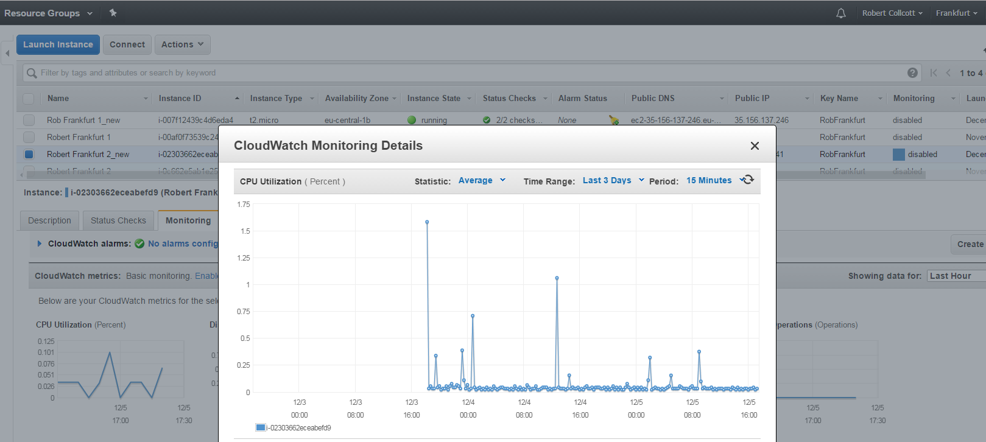

*Figure 21 Showing the following for the EU Frankfurt Instance 2*

* *Percentage of average stats of CPU Utilization with a view for first 3 days and 15 minutes’ cycle*

## CPU Credit Usage

Here I will be showing the sum of CPU Credit usage of my created instances

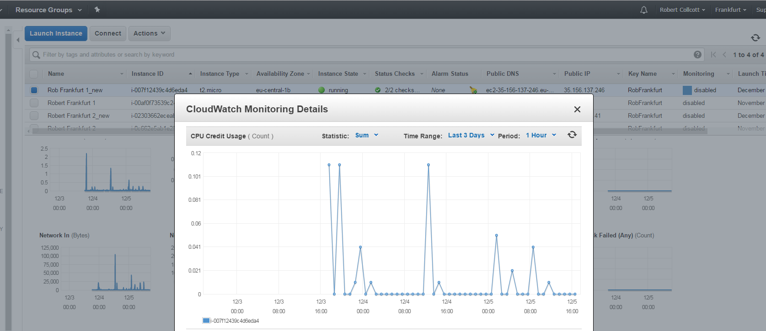EU Frankfurt

* Figure 22

Showing the EU Frankfurt Instance 2 sum CPU Credit usage for a three day period over a 1 hour cycle

* Showing the EU Ireland Instance 1 sum CPU Credit usage for a three day period over a 1 hour cycle

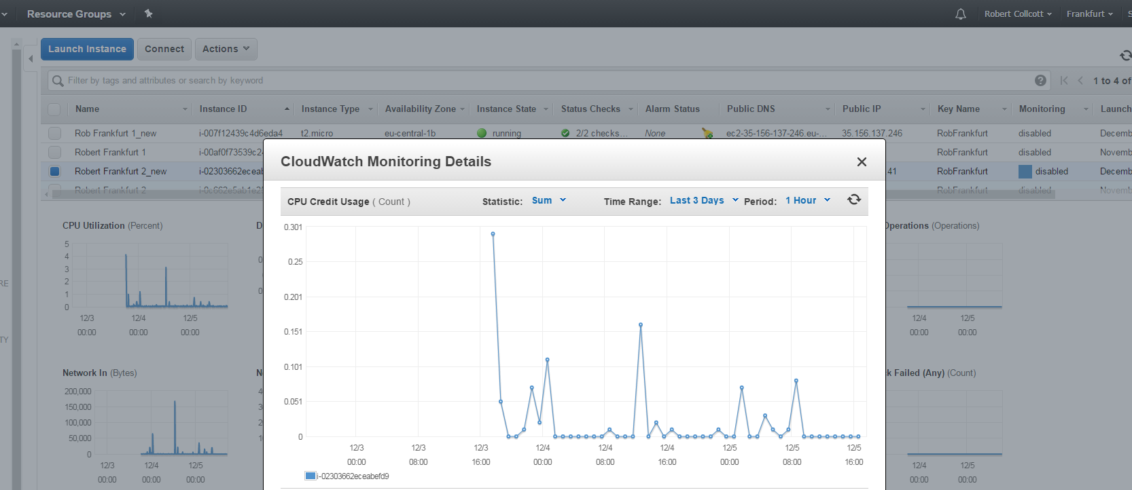

Figure 23

* Showing the EU Frankfurt Instance 2 sum CPU Credit usage for a three day period over a 1 hour cycle

## EU Ireland

Figure 24

* Showing the EU Ireland Instance 1 sum CPU Credit usage for a three day period over a 1 hour cycle

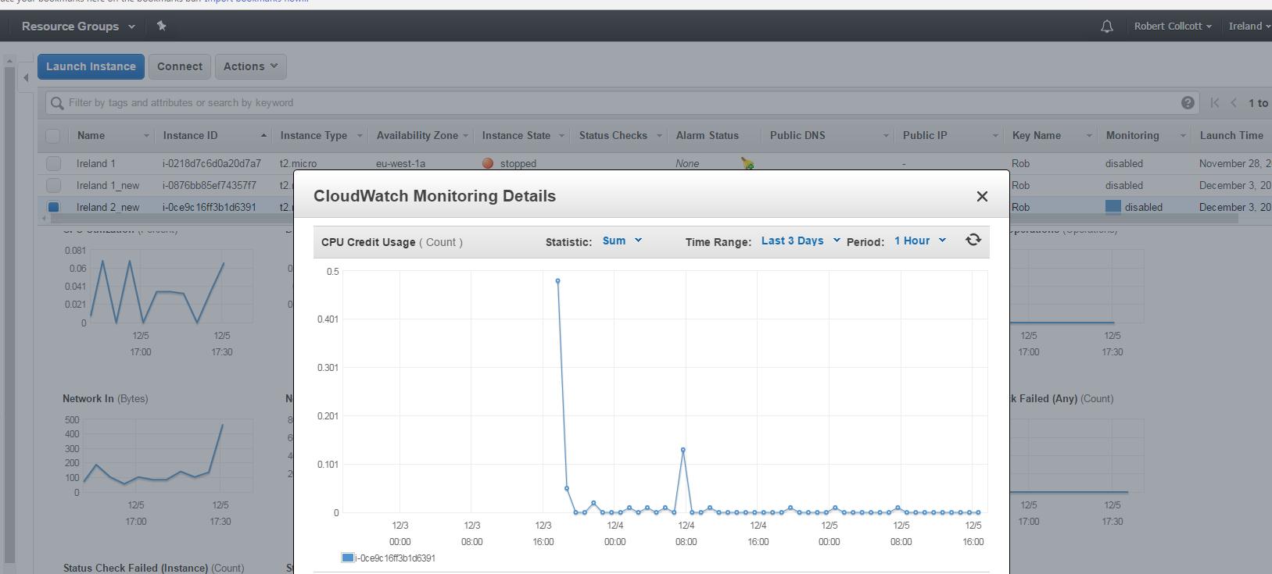

Figure 25

* Showing the EU Ireland Instance 2 sum CPU Credit usage for a three day period over a 1 hour cycle

## Amount of Bytes read in the same period

Here I will be showing the amount of bytes over a network over the first 2 days of the system

## EU Ireland

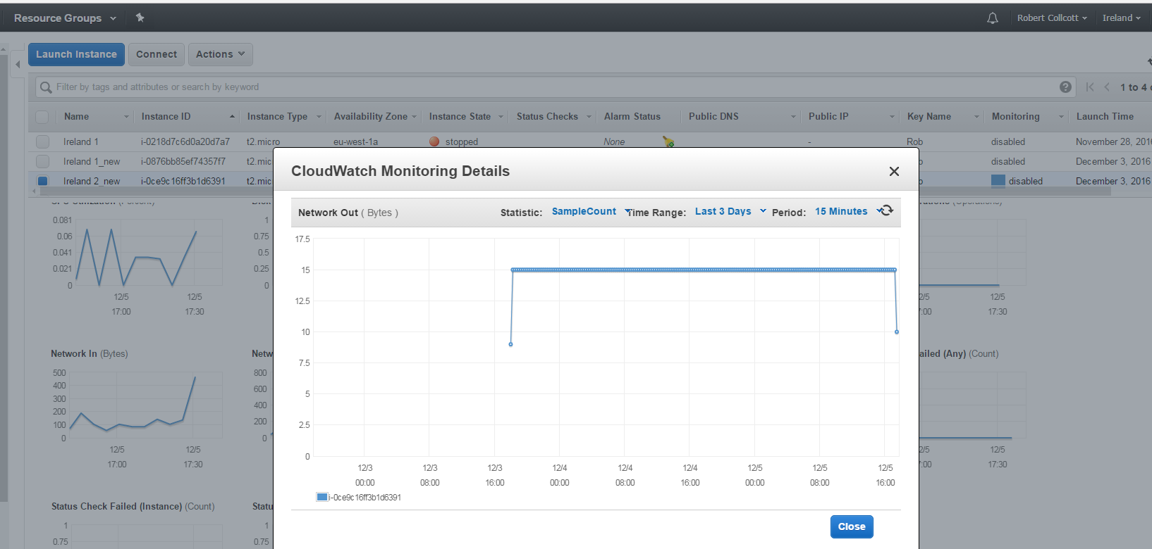

Figure 26

Showing the EU Ireland region instance 2 sample count amount of Bytes of data that have been read in a 3 day period and 15 minute cycle

## EU Frankfurt

Figure 27 Showing the EU Frankfurt region instance 1 sample count amount of Bytes of data that have been read in a 3 day period and 15 minute cycle

## Status of Failed instances during the last 3 days with 5 minute checks

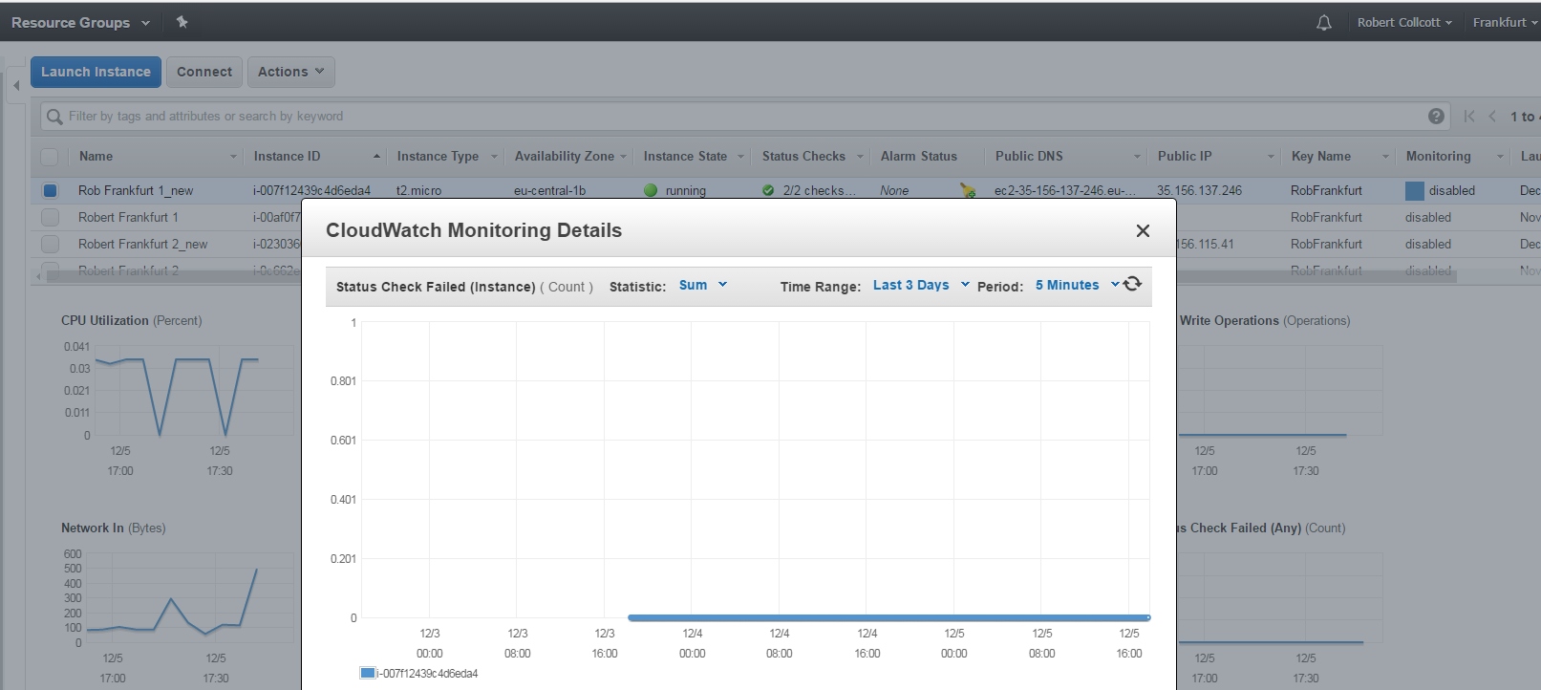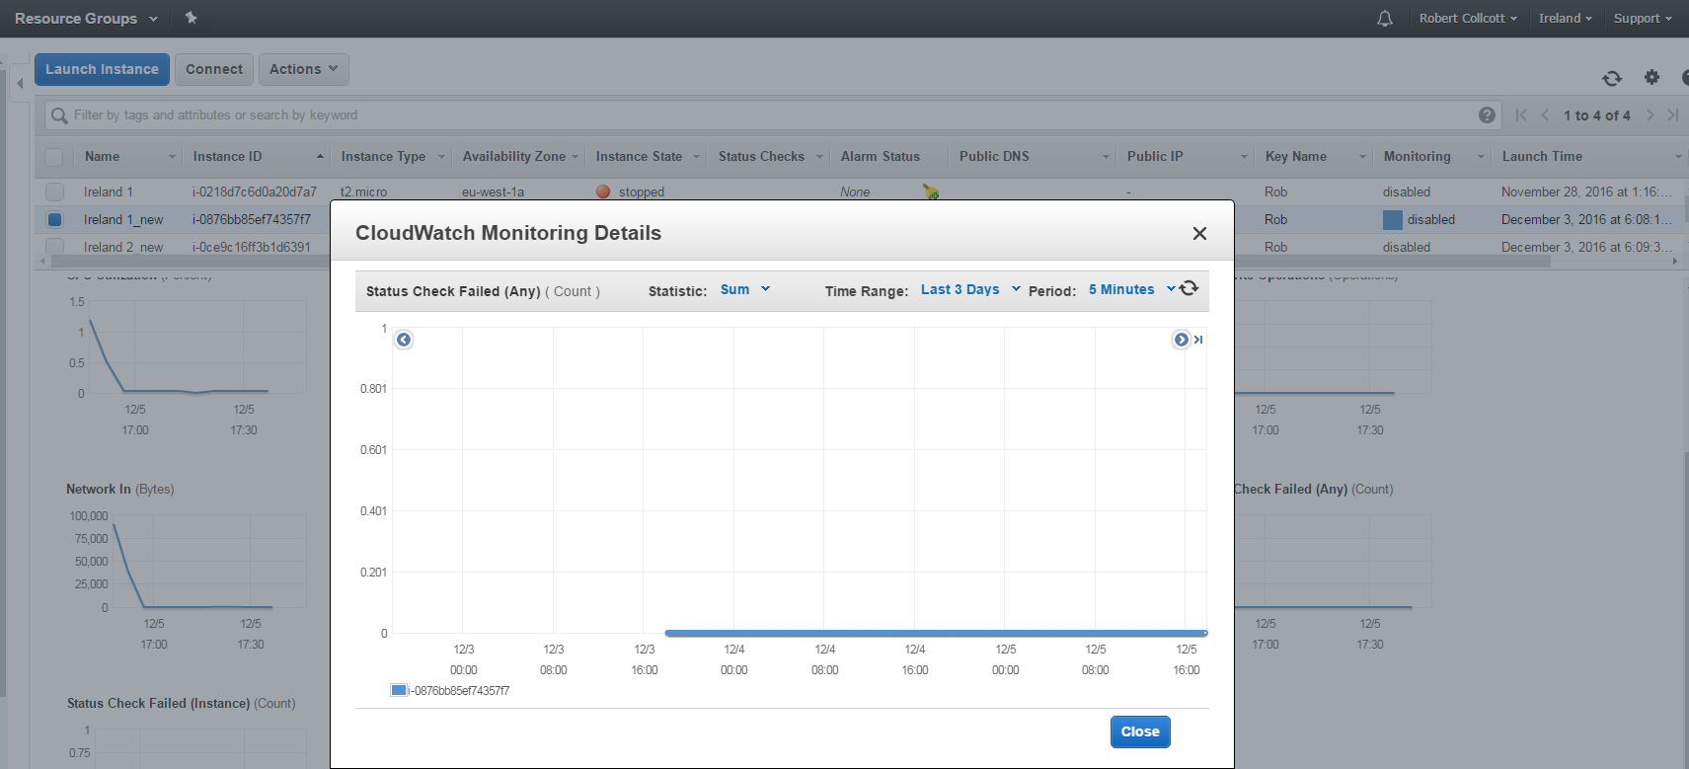

*Figure 29 Showing The Frankfurt EU Instance 1 failed instances*

Figure 28 Showing The Ireland EU Instance 1 failed instances

## Healthy and un healthy hosts on my cloud system for a three day period

## EU Ireland Region

Figure 30 Showing Un Healthy and Healthy Hosts on my cloud system for a three day period in the EU Ireland Region

*Using Instance named Ireland 1_new*

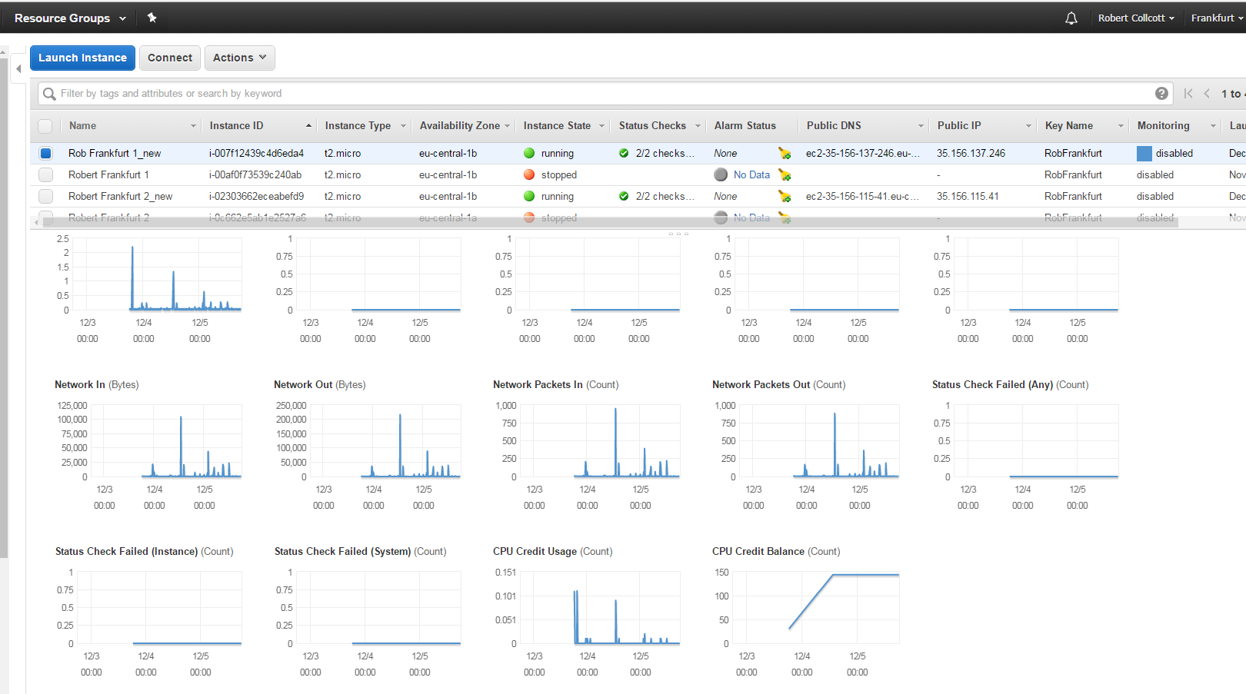

Figure 31 Showing Un Healthy and Healthy Hosts on my cloud system for a three day period in the EU Frankfurt Region

*Using Instance named Rob Frankfurt 1_new*

**Task 1C Technical Terms explained with technical definitions from technical computing sources**

**What actually is CPU Utilisation**

CPU utilization refers to computer’s usage of processing resources handled by a CPU this varies depending on the amount and type of managed computing tasks. Certain tasks will require heavy CPU time and some less, it all depends on the CPU resource requirements

CPU utilization may be used also to gauge system performance. For example, only running a few programs at a time might indicate insufficient CPU power support

**Bytes**

A byte is a unit that most computer systems use to represent a character such as letters numbers or something called a typographical symbol for example in my cloud system solution I could put in a number 1 declaring an instance name and the word instance itself also bytes can also handle strings.

**CPU Credit Balance**

This term is spilt into 2 parts CPU credit regulates the amount of CPU burst of an instance. Users of the AWS platform can spend their AWS credit to increase the CPU performance. On the other hand, the CPU credit balance is simply the credit a user of AWS would have available on a AWS account at an any moment during their usage of the AWS platform

The CPU credit usage identifies the amount of time which physical CPU’s were used for processing instructions by virtual CPU’s allocated to an instance on cloud computing platforms such as AWS., while the CPU credit balance is can burst beyond its baseline performance level at a particular given rate

## Task 1D -- Create your Cloud database, name your Buckets as “mycwdb”. Inside your Bucket do the following:

I used on Amazon Web Services to do the task above I used a AWS cloud based service named S3 which in full stands for the **Amazon Simple Storage service.** Amazon’s simple storage service allows me to store any amount of data anytime anywhere on the web and if I was developing my own web application it would allow me to build my own web applications

There was a new term in this task named Bucket.

**Bucket**

These are logical storage units in the Amazon Web service cloud computing platform they are used tis tire objects which consist of data such as word documents pics and videos etc and metadata which describes the data.

If a person was using the AWS S3 **Simple storage service.** They must create a bucket before they can store data in Amazon’s public cloud and specify access rights such as view and download

## Creation of two folders named fcone and fctwo

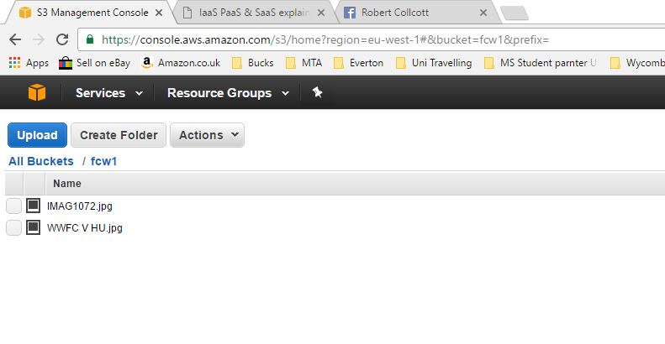

Figure 32 This is the two image files in bucket fcw1 as per instructed by the assignment brief

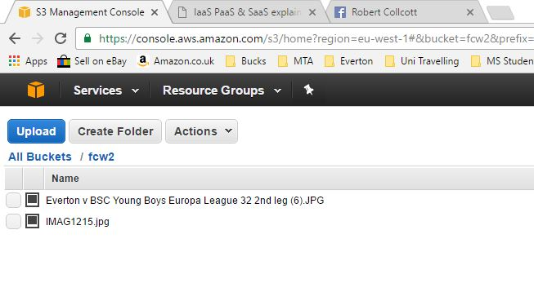

Figure 33 This is the two image files in bucket fcw2 as per instructed by the assignment brief

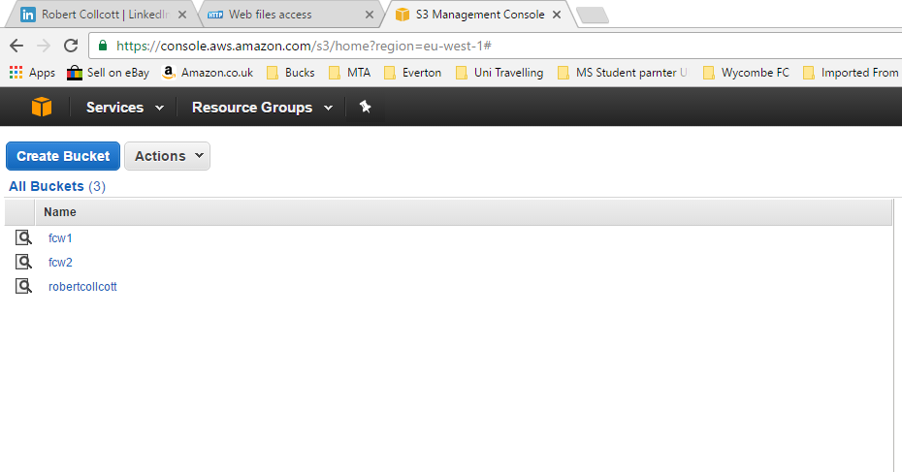

Figure 34 This is showing all the buckets created on my cloud system using the S3 which is the Amazon Simple Storage Service

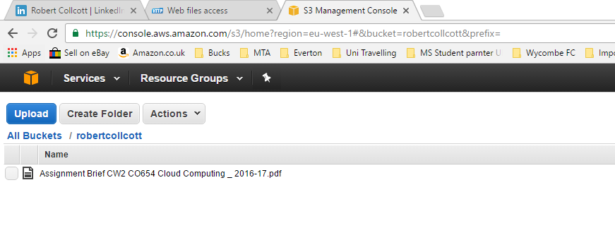

Figure 35 This is showing the second assignment brief for cloud computing stored on the database I created using the S3 the Amazon Simple Storage Service

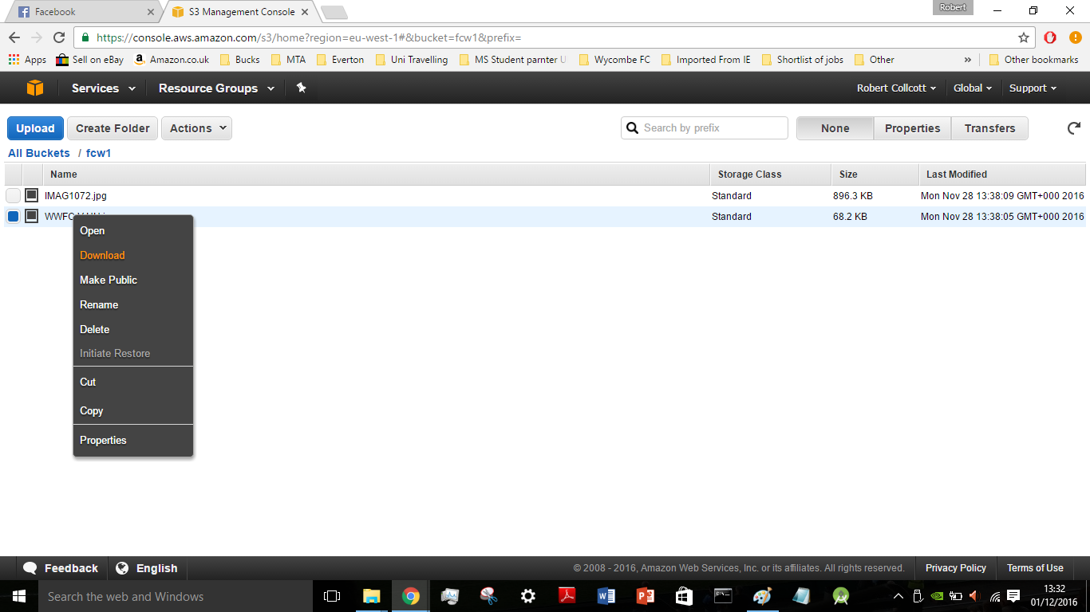

Figure 36 This is showing downloading a file from Amazon Web Services using the S3 Simple Storage Service

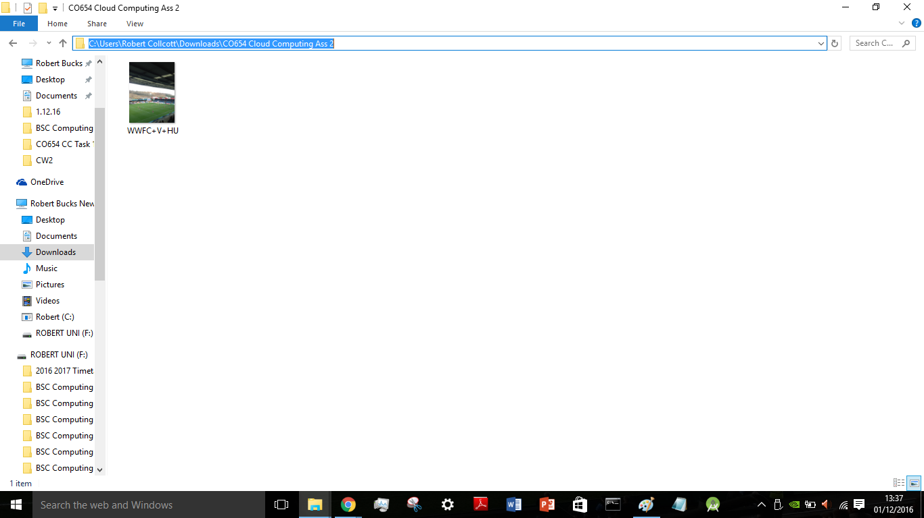

Figure 37 File path of downloaded file from Amazon S3 Simple Storage Service

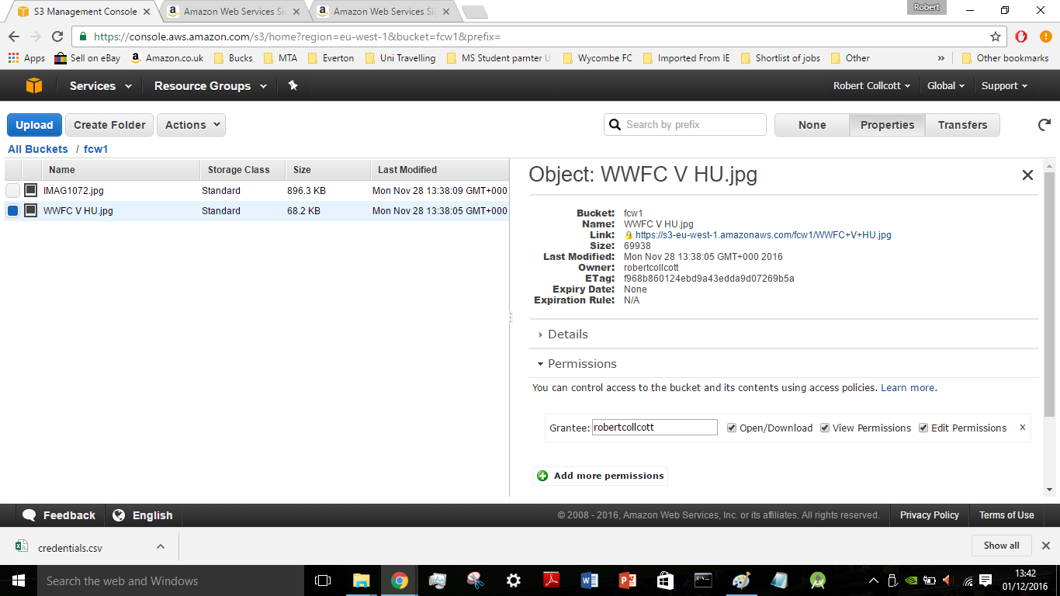

Figure 38 showing details of an uploaded file to the database using the Amazon S3 Simple Storage Service which were

***Bucket Folder Name Link Size Last Modified***

***Owner ETag Permissions***

Task 2

The Research Topic

**Topic 2**

**Cloud Based Models SASS PAAS and IAAS**

**+**

**AWS Case Study**

**A+ Test Prep and Tutoring**

## Task 2 – The Research Topic – Cloud Based Models [SASS PAAS and IAAS]

There are three cloud computing models used in the cloud computing industry these are however, they are also many different types of cloud computing as well see figure 20.

* Software as a Service
* Platform as a Service
* Infrastructure as a Service

Below is a technical description of cloud computing

## Cloud Computing Technical Definition

Cloud Computing is the delivery of computing as a service rather than a product typically shared resources and information are provided to computers and other devices as a metered service this is mostly the internet.

## Cloud Computing Types Model Typical types of cloud computing

Figure 39 The main types of cloud computing are around in today’s world of technology and their typical uses and users

***Reference***

*G, B. (2013) Cloud computing – types of cloud. Available at: http://bigdatariding.blogspot.co.uk/2013/10/cloud-computing-types-of-cloud.html (Accessed: 3 December 2016).*

* **Private**

Only used by single organisations

* **Community**

Used and shared by several organizations community cloud computing OS’s typically externally hosted however one business may decide to host it

* **Hybrid**

Two or more clouds that remain unique but are bound together hybrid is both internally and externally hosted

* **Public**

This type of cloud computing is owned and operated by a third party with a specialist for the delivery of superior economics for customers as the users are generally a mix giving each client machine at an attractive low cost public cloud computing is a typical pay as you go model. As all the customers, share some infrastructure with limited configuration

## Cloud Computing Models basic outline of characteristics

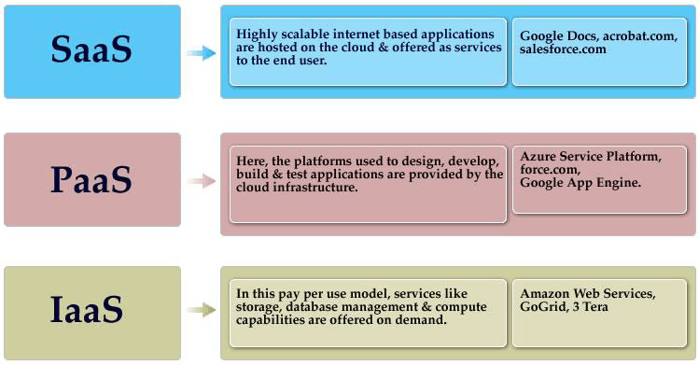

*Figure 40*

*Diagram of what characteristics SAAS PAAS and IAAS each have and industry used examples*

***Reference***

*Harris, T. (2016) Cloud computing overview. Available at: http://www.thbs.com/thbs-insights/cloud-computing-overview (Accessed: 3 December 2016).*

## Software as a Service [SASS Model Overview]

Three characteristics match out for software as a service as this is perhaps the most complex one of the three

Software as a Service includes

* Applications
* Management
* A standard User interface

Software as Service is typically provided over a network and consist of 4 major points these are

**Software Interface**

Provides a user with a complete software or user interface to use when the want to use the application itself

**Outsourced Management**

The cloud service provider manages the underlying cloud infrastructure which includes network OS’s storage and general application software such as Microsoft Office

**Thin interface**

The applications provided with thin interfaces so they can be accessed from various client devices e.g. tablets smart phones laptops and desktop computers running different operating systems e.g. one user running Windows 10 and another user running the Windows 7 OS

**Ubiquitous Access**

Users are able to access applications from anywhere such as the online outlook web app for checking email on the move

A typical example used in industry of a software as a service is the Microsoft Office 365 this is Office that works online just like the standard Office does but in the cloud you can get it for home business or education purposes.

The Office 365 platform typically contains the following programs and services

* Word
* PowerPoint
* Excel
* Outlook
* OneNote
* Access
* Project Professional
* Publisher
* 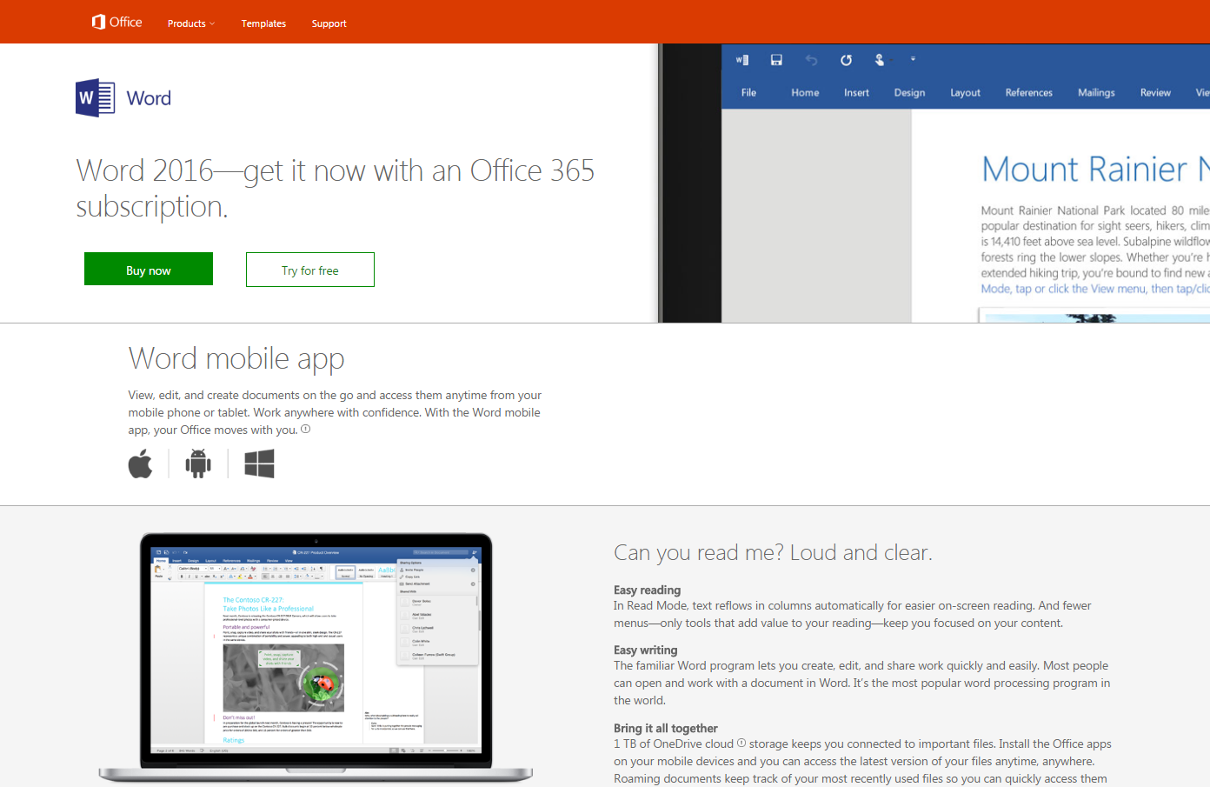Visio

Figure 41 Showcasing the Office 365 SASS Word app avaliable to a computer user

Reference

Google (2016) Google Images. Available at: https://images.google.co.uk/ (Accessed: 3 December 2016).

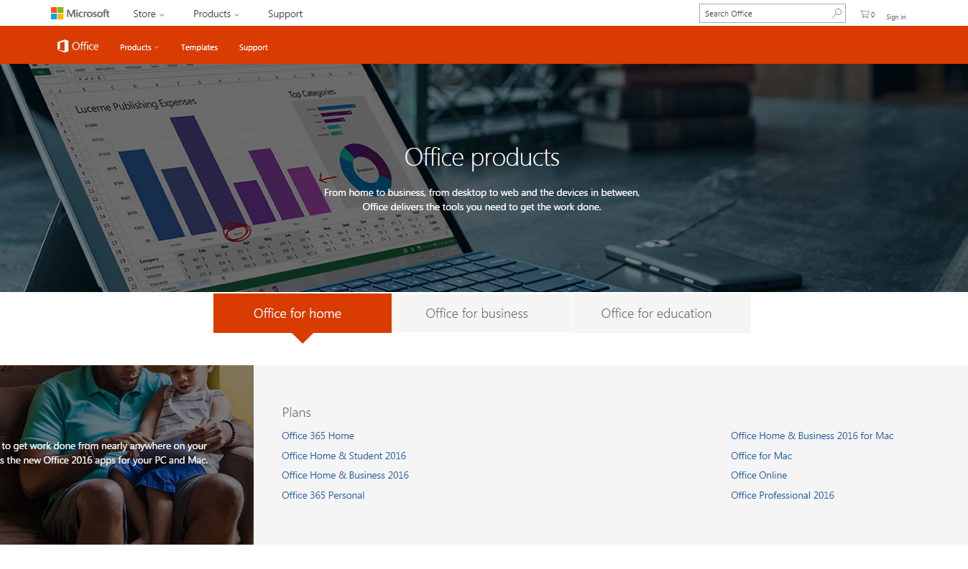

Figure 42 Typical Office 365 SASS Packages avaliable to a computer user

***Reference***

*Google (2016) Google Images. Available at: https://images.google.co.uk/ (Accessed: 3 December 2016).*

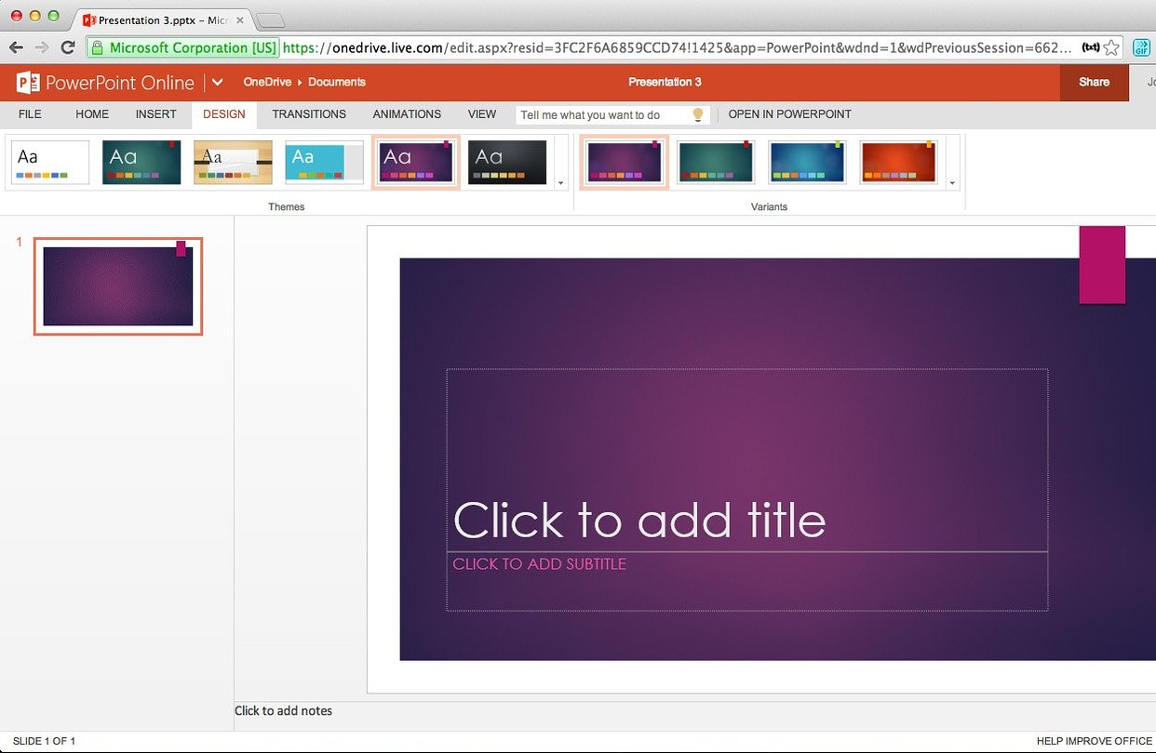

Figure 43 PowerPoint in use on Office 365 Software as a Service platform

***Reference***

*Google (2016) Google Images. Available at: https://images.google.co.uk/ (Accessed: 3 December 2016).*

## Basic characteristics of SAAS [Software as a Service]

1. Managing software from central locations
2. Commercial software such as the Microsoft Office 365 software tools can be accessed through the world wide web
3. Software patches and upgrades are automated for the user
4. Allow Application programming interfaces between various pieces of software

Table 1 The Advantages of Software as a Service

|  |  |
| --- | --- |
| Software as a Service Advantages | |
| **Advantage** | **Advantage description** |
| Customization | Easier to customize as they give exactly what the customer wants |
| Security | A trusted layer in the secure sockets this layer will permit the users to reach applications safely without having complex background configurations |
| Web Reliability | Generally the web is more reliable than any other source |
| More bandwidth | The quality of service is improved to perform better data flow which will help businesses access their applications with a decent speed and not much latency |
| Cheap | Using functionality of systems at a lower cost |
| Less Maintenance | Less setup time installation and monitoring of software |

Table 2 The Disadvantages of Software as a Service

|  |  |
| --- | --- |
| Software as a Service Disadvantages | |
| **Disadvantage** | **Disadvantage description** |
| Slower speeds | Running at slower speeds than client server applications |
| Control loss | In house software applications give businesses loads of control |
| Connectivity | Cannot use applications without an internet connection |

## PAAS Model overview

The PAAS model provides a computing that usually includes operating systems programming language running environments databases and web servers. Used by Application developers can develop and run their software solutions on a cloud platform taking away the cost of complex purchasing and managing hardware and software layers.

PAAS platforms however are not very common because they cannot offer the customer the control and variety they need for their applications

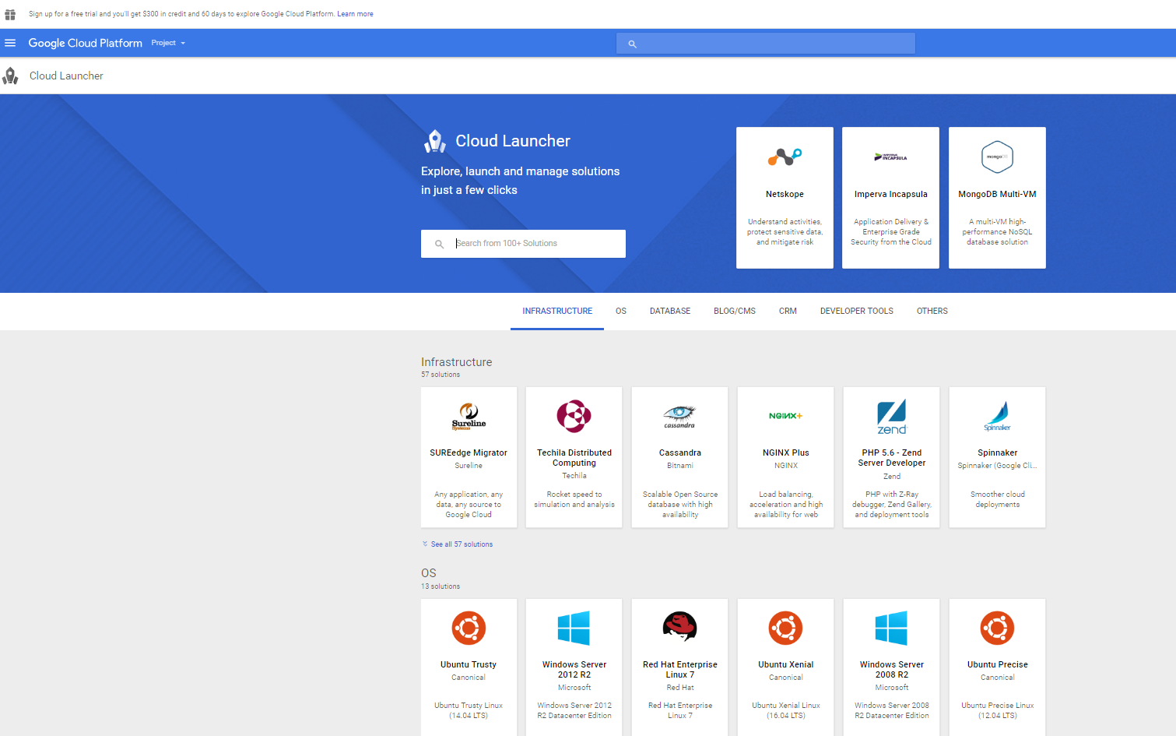

Figure 44 Google App Engine Industry example of Platform as a Service

**Reference**

Google (2016) Google Images. Available at: https://images.google.co.uk/ (Accessed: 3 December 2016).

**Google App Engine**

An industry example of platform as a service Google app engine you can choose what language you want to developer in these include Java PHP and even old fashioned languages like Python and Node.

Google App Engine has the following selling points for a user to consider these are

* Future proof infrastructure – Google App Engine is secure global has high performance and constantly improving
* Powerful data & analytics – Find big data to find answers faster to build better quality products such as web apps
* Just coding – grow from the prototyping stage to production stage without having to think about capacity reliability and the performance.

The platform as a service model typically has 3 main characteristics which are the following

* Development and Deployment
* Provider Manages Infrastructure
* User Manages the application

Typically, PAAS the platforms are used to design develop build and test applications these are provided by the cloud infrastructures some industry examples of these include

* Microsoft Azure
* Google’s App Engine
* Force.com

Table 3 The Advantages of Platform as a Service

|  |  |
| --- | --- |
| Platform as a Service Advantages | |
| **Advantage** | **Advantage description** |
| Customization | Easier to customize as they give exactly what the customer wants |
| Security | A trusted layer in the secure sockets this layer will permit the users to reach applications safely without having complex background configurations |
| Web Reliability | Generally the web is more reliable than any other source |
| More bandwidth | The quality of service is improved to perform better data flow which will help businesses access their applications with a decent speed and not much latency |
| Cheap | Using functionality of systems at a lower cost |
| Less Maintenance | Less setup time installation and monitoring of software |

Table 4 The Disadvantages of Platform as a Service

|  |  |
| --- | --- |
| Platform as a Service Disadvantages | |
| **Disadvantage** | **Disadvantage description** |
| Customer captivity | There are limited PAAS vendors in today’s market and each competing against other and this limits the client’s choice of what particular platform to go for |
| Data security | With other cloud computing solutions, many companies still have low confidence in the level of data security offered by PaaS. Many businesses are still skeptical about having their applications hosted by a third party |
| Limited flexibility | PaaS customers cannot necessarily create and delete multiple virtual machines easily |

## Infrastructure as a Service

An example of this is the Amazon EC2 this is a web service that provides a resizable computing capacity in the cloud which allows businesses to obtain and configure capacity within a minimal friction. It provides control of computing resources and lets organizations run on the Amazon computing environment.

The Amazon EC2 reduces the time required to obtain and boot new server instances this allows quick scaling capacity both up and down as computing requirements change Amazon EC2 unlike many other cloud computing platforms only chargers the economics of computing by allowing you to pay only for capacity you as a user of the platform actually use.

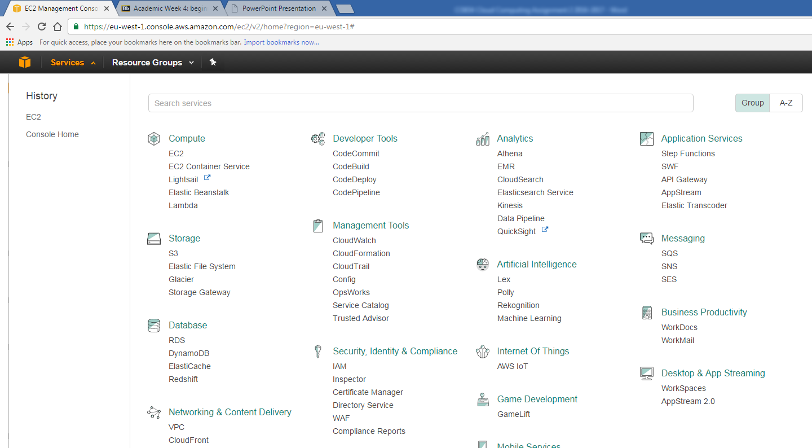

Figure 45 The Amazon Web Services Dashboard industry example of Infrastructure as a Service

Some key components of the infrastructure as a service cloud computing based model are

**Load balancing**

Enables customers to balance incoming requests and distribute traffic across multiple Amazon EC2 compute instances

**Auto scaling**

Automatically grows and shrink’s usage of Amazon EC2 compute capacity based on application requirements

**Monitoring**

Enables customers to monitor operational metrics of the Amazon EC2 service providing even better visibility into usage of the AWS cloud

**Management Console**

This is providing a simple point and click web interface that lets customers manage and access AWS cloud resources.

## IAAS Model overview

Here is the Infrastructure, as a service model Infrastructure as a service typically works like the following as shown in figure 26

The IASS model of cloud computing represents a self-contained IT environment comprised of infrastructure centric IT resources that can be accessed and managed via a cloud based interface and tools. The model includes

* Hardware
* Networking
* Connectivity
* Operating Systems

**What the IASS model does.**

The IASS model provides cloud consumers with a high level of control and responsibility over the configuration and utilization. The computing resources provided by IAAS are pre-configured placing the admin rights directly on the consumer. Therefore, it is important by the cloud consumers require a high level of control over the cloud based environment they intend to use and create. For example, when I was using AWS to create my cloud system for this assignment I could have assigned certain permissions to a user who wanted to access resources such as open only not download etc.

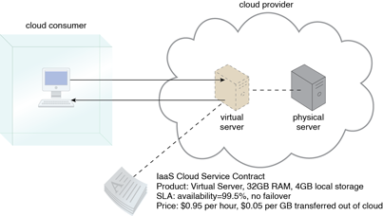

Figure 46 Typical IASS process with a client consumer with a virtual server and configured to his or her’s needs

**Reference**

IncArcitura™Education (2016) What is cloud computing? Available at: http://whatiscloud.com/cloud_delivery_models/infrastructure_as_a_service (Accessed: 3 December 2016).

Table 5 The Advantages of Infrastructure as a Service

|  |  |
| --- | --- |
| Infrastructure as a Service Advantages | |
| **Advantage** | **Advantage description** |
| Saves IT staff time | The cloud provider takes care of any faults for you |
| Subscription based | You only pay for the services you use |
| Focus on priorities | Scaling the business maximizing tasks relating to the business |
| Free from limitation | Solving the endless treadmill of upgrading and purchasing new technology for your IT staff |

Table 6 The Disadvantages of Infrastructure as a Service

|  |  |
| --- | --- |
| Infrastructure as a Service Disadvantages | |
| **Disadvantage** | **Disadvantage description** |
| Expensive | The provider can charge for every bit of RAM and disc spaced used |
| Backup of data | You as the admin or customer or responsible for backing up the data |
| Management | All users are responsible for the VM management |

## Industry examples of how infrastructure can be used by an enterprise such as Amazon Web Services

**Cloud Hosting**

This applies to all the hosting of websites on virtual servers which are founded upon pooled resources from underlying physical servers. One benefit in particular on cloud hosting is the redundancy provided by the vast network of physical servers

**Scalability**

The resources are available when the client needs it to they are no delays in exceeding capacity or the wastage of unused capacity

**No single point of failure**

If one server or network switch fails. The broader service would be unaffected due to the remaining multitude of hardware resources and redundancy configurations. For example, in industry if one entire data centre was to go offline with just one server down the IASS could still run successfully.

**Utility style costing**

The service can still be accessed on demand and the client user only pays for the actual service they actually use. For example, in Microsoft Azure I would only be paying for the storage service should I choose to use that service and no other service

## Security Concepts

Now we are going to be dealing with some of the fundamental security concepts of the SAAS PAAS and IAAS cloud based models as this is important to understand

**SAAS**

Is mainly responsible for managing access to applications and the policy controls may dictate to a sales person that can only download certain particular information from a Customer Relationship Management System and within a time zone such as the office working hours. In theory, what should be happening is the security team of techies needs to focus in establishing control regarding the applications focus

**PAAS**

PAAS has got the focus for maintaining data there is something used here called ab load balancer which is a tool used to make sure access providers of the ability outrage, another key concept to understand has to be the encryption of data.

**IAAS**

IAAS has the focus on managing virtual machines such as using the Microsoft Azure platform there should be a policy in place on how VM’s are created and spun day thus avoiding un controlled access and westerly cost

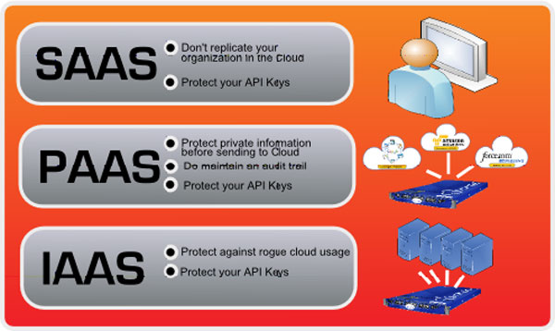

Figure 47 Key Security Concepts within Software as a Service Platform as a Service and Infrastructure as a service

*Reference*

*Google (2016) Google Images. Available at: https://images.google.co.uk/ (Accessed: 3 December 2016).*

## SAAS PAAS and IAAS detailed features comparison

Table 7 Comparison Features Grid of the fundamental Cloud Computing Models

**Reference**

Hosting, L. (2016) IaaS PaaS & SaaS explained with examples & Comparison. Available at: http://blog.webspecia.com/cloud/iaas-paas-saas-explained-examples-comparison (Accessed: 29 November 2016).

|  |  |  |  |
| --- | --- | --- | --- |
| Cloud Computing Models Comparison of Features | | | |
| Feature | **Cloud Computing Model** | | |
| IAAS  **Infrastructure as a Service** | PAAS  **Platform as a Service** | SAAS  **Software as a Service** |
| What a user gets | Paying according for freedom to use and install and any operating system | What a user demands such as software hardware operating system and web environment | No worries about anything all software is pre-configured and pre-installed |
| Technical Difficulties | Lots of technical knowledge required typical people are network architects | Knowledge of the subject area of computing is an added bonus | The provider handles everything |
| Popularity among users | Highly skilled developers who require lots of custom configurations | Developers that focus on own apps or scripts without the need to worry about traffic load or a server’s management | Normal everyday computer users that use basic applications such as email file sharing and social networking |
| Payment Required | Yes to be able to use the software such as a server | Yes to be able to use the software such as an operating system | No as everything is pre-installed maintained and in large businesses the computing administrators manage payments for the whole business which would include yourself |

## SASS PASS and IASS Economic Benefits

**People**

Companies rely on fewer staff, by having fewer staff members you can look at your team and decide

**Hardware**

Exceptions to large businesses governments or major cloud suppliers can purchase hardware networking equipment bandwidth so much cheaper than a regular business. This means you will need more storage

**Pay as you go**

Like renting a car or house hear It’s the same within the cloud computing industry such as using Amazon web services as you as the user may not be happy with what you have setup such as an instance or a server

## Case Study - A+ Test Prep and Tutoring overview

A+ test prep and tutoring was created for students to prepare for SATS and ACT exams as well as many additional ones such as English Maths and Science

So it is a school or American college based type of environment the case study is based on and they are several problems within the organisation these are and A+ is looking to expand the company resources to work with students oversees and to order to do this A+ needed a hosting environment

There was a developer appointed named Jell Networks to analyse the following aspects for A+ in order for them to sort things for the upgrade to a cloud provider. Jell had to evaluate the following areas for consideration as when putting in a cloud provider the following below are very important to consider as you don’t won’t hackers hacking in making sure everything is compatible as software must be able to run everywhere

One of the biggest things also is the performance is users need to be able access whenever they are e.g. on a train bus or just in front of their own home.

**Security**

There needs to be a way for adding internal users very easily and changing access permissions very easily too.

**Scalability**

50% the intake is going up in the test preparation market they needed to be to support new students without any additional hardware

**Compatibility**

The cloud platform for A+ test prep and tutoring has to be compatible with third party open source tools

**Performance**

There needs to be low network latency and performance must be at the best level possible

**Reliability**

A+ needs 100% reliability as possible

## Case Study - A+ Test Prep and Tutoring suggestions

Following on from analysing the case study with the points above

There were some ways I think **A+ test prep and tutoring** can go about solving the problems above these include the following below

**Research Technique Option 1**

Research alterative platforms available for the points above and justify the thoughts

**Research Technique Option 2**

Research alterative platforms still, compare them with the points above, and include columns for price general notes and features available this will help the manager as this way he can share more easily his thoughts easier with other team members in the company to gather people’s thoughts

**Get in contact with other cloud system professionals via Skype LinkedIn etc.**

There will be no harm in asking other experts in cloud based systems as the more opinions you have on a project the better it will become to come to a conclusion to decide which solution is best for A+ test prep and tutoring because you are getting knowledge from experts in the industry

**Outline an Initial Specification**

This helps projects like the A+ Test prep and tutoring has if you outlined an initial spec of what is needed and if done on an excel file they could use the filter tool by risk scale e.g. High Medium and Low.

**Outline Advantages and Disadvantages of other potential cloud platforms [via online articles whitepapers and general images]**

A+ test prep and tutoring could browse online articles posted by other users of cloud computing platforms or industry professionals to see what the advantages and disadvantages are of each.

General images could also come in, as these will help A+ test prep and tutoring in deciding the user experience and interface factors, as when considering a move to a cloud system with the points on the pervious page. The UX is important as the users that will going to growing the company need to be able to use the system without any hassle and troubles.

## Cloud Computing Assignment 2 References List

**Reference 1 - IaaS PaaS & SaaS explained with examples & Comparison**

Hosting, L. (2016) IaaS PaaS & SaaS explained with examples & Comparison. Available at: http://blog.webspecia.com/cloud/iaas-paas-saas-explained-examples-comparison (Accessed: 29 November 2016).

**Reference 2 – Advantages of IAAS**

IT Solutions, C. (2014) What are the advantages of infrastructure-as-a service (cloud hosting)? |

**Reference 3 – IASS model advantages**

Continū IT solutions. Available at: http://continu.net/what-are-the-advantages-of-infrastructure-as-a-service-cloud-hosting/ (Accessed: 30 November 2016).

**Reference 4 – Summary of IASS PAAS and SAAS + pros and cons**

Media, S.-C. (2012) Brief summary of IaaS, PaaS, SaaS. Available at: http://cloudcomputing.sys-con.com/node/2218739 (Accessed: 30 November 2016).

**Reference 5 – Security Concepts for SASS PAAS and IAAS**

O’Neill, M. and Vordel (2011) SaaS, PaaS, and IaaS: A security checklist for cloud models. Available at: http://www.csoonline.com/article/2126885/cloud-security/saas--paas--and-iaas--a-security-checklist-for-cloud-models.html (Accessed: 30 November 2016).

**Reference 6 – Text book given from Rafid**

Velte, T.J., Velte, A.T. and Elsenpeter, R. (2009) Cloud computing, a practical approach. New York: McGraw-Hill/Osborne Media 22 October.

**Reference 7 IASS model disadvantages**

Ventures, G. (2001) Disadvantages of SaaS - software as a service. Available at: http://www.gaebler.com/Disadvantages-of-SaaS.htm (Accessed: 30 November 2016).

**Reference 8 – further advantages and disadvantages**

Admin (2015) Advantages and disadvantages of SaaS, PaaS and IaaS. Available at: http://aiasecurity.com/2015/09/10/advantages-and-disadvantages-of-saaspaas-and-iaas/ (Accessed: 30 November 2016).

**Reference 9 – Rafid’s helpful presentation and lecture notes**

Al-Khannak, R. (2016) Cloud Computing Introduction & Concepts. Available at:

https://my.bucks.ac.uk/bbcswebdav/pid-1650619-dt-content-rid-965887_1/courses/CO654-16S1/CO654%20Cloud%20Computing %20-%20Week%204.pdf (Accessed: 24 November 2016).

**Reference 10 – Text given from Rafid**

Sosinsky, B.A. (2011) Cloud Computing Bible. Indianapolis, IN: John Wiley [distributor] 7 January.

**Reference 11 – What does Amazon Cloud Watch do**

AWS (no date) Amazon CloudWatch FAQs. Available at: https://aws.amazon.com/cloudwatch/faqs/ (Accessed: 3 December 2016).

**Reference 12 – Infrastructure as a service overview**

IncArcitura™Education (2016) What is cloud computing? Available at: http://whatiscloud.com/cloud_delivery_models/infrastructure_as_a_service (Accessed: 3 December 2016).

**Reference 13 – What does VPC stand for on AWS**

AWS (2016a) Amazon virtual private cloud (VPC) – Amazon web services. Available at: https://aws.amazon.com/vpc/ (Accessed: 3 December 2016).

**Reference 14 – Private IP v Public IP Addresses**

Location, I. (2006) What is the difference between public and private IP address? Available at: https://www.iplocation.net/public-vs-private-ip-address (Accessed: 3 December 2016).

**Reference 15 – Cons of Software as a Service**

2015 (2001) Disadvantages of SaaS - software as a service. Available at: http://www.gaebler.com/Disadvantages-of-SaaS.htm (Accessed: 3 December 2016).

**Reference 16– Internal [Private] v External [Public] DNS the difference between**

Answers, Y. (2009) What is the different between internal DNS and external DNS? Available at: https://answers.yahoo.com/question/index?qid=20090117104241AAh7akV (Accessed: 3 December 2016).

**Reference 17– Why Google app engine supporting industry example for platform as a service section**

Google (2016c) Why Google’s cloud infrastructure is right for your business | Google cloud platform. Available at: https://cloud.google.com/why-google/ (Accessed: 3 December 2016).

**Reference 18 – Image of the typical types of cloud computing**

G, B. (2013) Cloud computing – types of cloud. Available at: http://bigdatariding.blogspot.co.uk/2013/10/cloud-computing-types-of-cloud.html (Accessed: 3 December 2016).

**Reference 19 CO654 Cloud Computing CW2 Report Supporting Industry examples pictures**

Google (2016) Google Images. Available at: https://images.google.co.uk/ (Accessed: 3 December 2016).

**Reference 20 Technical Explanations of CPU Credit Usage and CPU Credit Balance**

Stack Overflow (2016e) Whats is CPU credit balance in EC2? Available at: http://stackoverflow.com/questions/28984106/whats-is-cpu-credit-balance-in-ec2 (Accessed: 5 December 2016).

AWS (2016c) T2 instances. Available at: http://docs.aws.amazon.com/AWSEC2/latest/UserGuide/t2-instances.html#t2-instances-cpu-credits (Accessed: 5 December 2016).

**Reference 21 Technical Explanations of CPU Utilization**

Institute, S. (2016) What is CPU utilization? - definition from Techopedia. Available at: https://www.techopedia.com/definition/28291/cpu-utilization (Accessed: 5 December 2016).

**Reference 22 Technical Explanation of computing word Bytes**

Rouse, M. (2006) What is byte? - definition from WhatIs.com. Available at: http://searchstorage.techtarget.com/definition/byte (Accessed: 5 December 2016).

**Reference 23 Technical Explanation of cloud computing word Bucket**

Rouse, M. (2014a) What is bucket (AWS bucket)? - definition from WhatIs.com. Available at: http://searchaws.techtarget.com/definition/AWS-bucket (Accessed: 5 December 2016).

**Reference 24 – Security Checklist for SASS PAAS and IAAS**

O’Neill, M. and Vordel (2011) SaaS, PaaS, and IaaS: A security checklist for cloud models. Available at: http://www.csoonline.com/article/2126885/cloud-security/saas--paas--and-iaas--a-security-checklist-for-cloud-models.html (Accessed: 30 November 2016).